Beautician Blog App

A PROJECT REPORT

BACHELOR OF SCIENCE

(Computer Science)

SUBMITTED BY

Palla Vasantha Kumari

Team LTVIP2023TMID08382

Sri Vivekananda Degree College

(Recognised by Andhra University)

SRI VIVEKANANDA DEGREE COLLEGE, KASIMKOTA,VISHAKAPATNAM, ANDHRAPRADESH, INDIA.

# INTRODUCTION

Beautician Blog App provides brief information about the how beauty kits are useful. This project comprises of two files. First is the HTML file for creating markup of the application on the web. Then CSS file is used to provide more styles to the website.

# DECLARATION

To the best of my knowledge and belief, this project is based on my own work, all sources have been properly acknowledged, and the project follows the guidelines as mentioned by the blog app. I assure that this project does not violate any copy right from anyone.

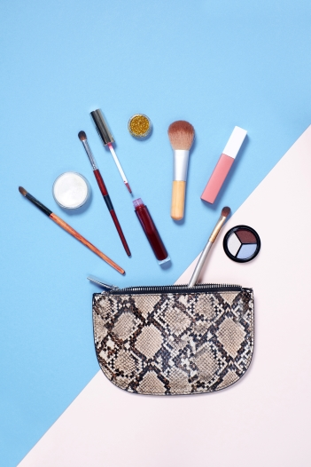

# SOFTWARE USED

Code Editor I used for this project is VS Code, It is used to code complex piece of programs and to develop complex projects. Further technologies I used for this project are HTML, CSS .

2.1 HTML

It is the code for creating web pages, using tags and other commands that a browser rends and eOiiVCi'tS into the iiOt'iÄiiil web pages that people see.

2.2 css

CSS is the language for describing the presentation of Web pages, including colours, layout, and fonts.

Result / Output

Home Section:

It displays the beautician kits, it includes the makeup kit, like brushes,lipstick,eyeline and subscribe of my website and my contact detail shortcuts on bottom of the app. 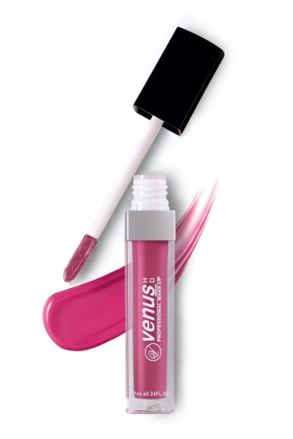

About Section:

It displays a quick introduction for me and provides my skills and education.

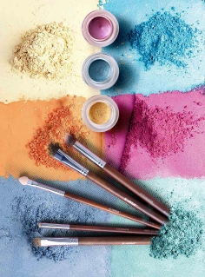

Contact Details Section:

This section has all the links listed below :

I. Facebook

1. Twitter
2. Whatsapp
3. Instagram
4. Linked In

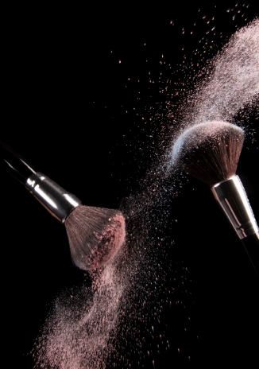

Applications:

Linking google drive files like my beauty images and my documents.

Spacing out the elements properly using CSS.

Conclusion;

At last to conclude, I have developed a simple and basic beautician blog app using HTML 5, CSS, using VS Code as IDE which I would continue to maintain in future too,

Future Scope:

The scope of a standand beautician blog is defined by it's component projects and programmes where as the scope of a structured blog app is defined by the strategic beauty kits as it is designed to achieve.